# CHAPTER-1

# INTRODUCTION

# Food ordering system is an application which will help restaurants to optimized and control over these restaurants. For the management point of view, the manager will be able to control the restaurant by having all the reports and able to see the records of each employees and other. This application helps the restaurant to do all functionalities more accurately and faster way. Food ordering system reduces manual works and improves efficiency of restaurants.

# The main goal is to maintain the restaurant’s functions in an effective and accurate manner and also it is reducing the use of manual entries. This software helps food orders to maintain day to day records in system.

# 

# 1.1 Project Description

# 1.1.1 Statement Of Problem

# Many restaurants is storing all of their data in manual way. They have huge number of customers daily. So because large numbers of customers, they need the help of some features so they can maintain and store the records accurately. For managers it is difficult to view the quality, orders.

# They need a full-fledged software to maintain their day to day transactions, orders and also regular update on records, each transaction, customers feedbacks etc. In the existing system, entering all the details are done manually, it is taking lots of time and also there are chances for mistakes.

# 1.1.2 Purpose

The purpose of the online food delivery system is to simplify and automate the process of searching for food items and maintain the records of food orders, now the food items can be ordered through this application.

# 1.1.3 Project Scope

The system is used for maintaining all the process and activities of online food delivery system. The system can be extended to be used for maintaining records of foods orders. While developing the system, there shall be space for further addition of features. There shall be a proper documentation so that further enhancement becomes an easy process.

# 1.2 HTML5

HTML, which stands for Hyper Text Mark-up Language, is the predominant mark-up language for web pages. It provides a means to create structured documents by denoting structural semantics for text such as headings, paragraphs, lists etc as well as for links, quotes, and other items. It allows images and objects to be embedded and can be used to create interactive forms. It is written in the form of HTML elements consisting of "tags" surrounded by angle brackets within the web page content. It can include or can load scripts in languages such as JavaScript which affect the behavior of HTML processors like Web browsers; and Cascading Style Sheets (CSS) to define the appearance and layout of text and other material. The W3C, maintainer of both HTML and CSS standards, encourages the use of CSS over explicit presentational mark- up.

# 1.3 PHP

Hypertext Pre-processor, is a widely used, general-purpose scripting language that was originally designed for web development, to produce dynamic web pages. It can be embedded into HTML and generally runs on a web server, which needs to be configured to process PHP code and create web page content from it. It can be deployed on most web servers and on almost every operating system and platform free of charge.

**1.4 CSS3**

Cascading Style Sheets (CSS) is a style sheet language used for describing the presentation of a document written in a mark-up language like HTML. CSS is designed to enable the separation of presentation and content, including layout, colours, and fonts. This separation can improve content accessibility, provide more flexibility and control in the specification of presentation characteristics, enable multiple web pages to share formatting by specifying the relevant CSS in a separate. Css file, and reduce complexity and repetition in the structural content.

**1.5 JAVA**-**SCRIPT**

JavaScript often abbreviated as JS, is a high-level, interpreted programming language. It is a language which is also characterized as dynamic, weakly typed, prototype-based and multiparadigm. Alongside HTML and CSS, JavaScript is one of the three core technologies of the World Wide Web. JavaScript enables interactive web pages and thus is an essential part of web applications.

# CHAPTER-2

# SOFTWARE REQUIREMENT SPECIFICATION

# 2.1 Functional Requirements

These are statements of services the system should provide, how the system should react to particular inputs and how the system should behave in particular situations. In some cases, the functional requirements may also explicitly state what the system should not do. The functional requirements for a system to describe what the system should do. These requirements depend on the type of software being developed, the expected users of the software and the general approach taken by the organization when writing requirements. When expressed as user requirements, the requirements are usually described in an abstract way. However, functional system requirements describe the system function in detail, its inputs and outputs, exceptions, and so on.

# 2.2 Non-Functional Requirements

Non-functional requirements are requirements that are not directly concerned with the specific functions delivered by the system. They may relate to emergent system properties such as reliability, response time and store occupancy. Alternatively, they may define constraints on the system such as the capabilities of I/O devices and the data representations used in system interfaces. The plan for implementing functional requirements is detailed in the system design. The plan for implementing this is detailed in the system architecture.

* Execution qualities, such as security and usability, which are observable at run time.
* Evolution qualities, such as testability, maintainability, extensibility and scalability, which are embodied in the static structure of the software system

The Non-functional Requirements of the project are as follows:

* First, we need to build a program in using php and html, then we can perform a certain operation & the constraint will be given to operate on the output screen.
* You can see different modes of working of the project by selecting various buttons or by selecting links.

# CHAPTER-3

# REQUIREMENT ANALYSIS

## 3.1 Introduction

A software requirements specification (SRS) is a comprehensive description of the intended purpose and environment for software under development. The SRS fully describes what the software will do and how it will be expected to perform. Software requirements specification establishes the basis for an agreement between customers and restaurants on what the software product is to do as well as what is not expected to do. It should also provide a realistic basis for estimating product costs, risks, and schedules. Software requirement specification prevents software project from failure.

## 3.2 Hardware requirement

## Processor : Intel i3, 2.0GHZ machine or above.

## RAM : 4 GB Ram or above.

## Cache : 512 KB Cache Memory

## Storage : Hard disk 1 GB

## Monitor : 64-bit color.

## 3.3 Software requirement

## Operating System : Windows 10

## Programming Language : HTML, CSS, JAVASCRIPT, PHP

## Data-Base : MYSQL

## Web Server : XAMPSERVER

# 

# CHAPTER-4

# ANALYSIS AND DESIGN

The design phase seeks to detailed specifications that emphasize the physical solution to the project.

**4.1 Modular Diagram**

Modular diagrams are used to show the allocation of classes and objects to modules in the physical design of a system, that is module diagrams indicate the partitioning of the system architecture. The two essential elements of a module diagram are modules and their dependencies.

These are the module present in the Online Food Delivery System.

1. **LOGIN MODULE**
   * Entering the name of the user/admin
   * Entering the password of the user/admin
2. **REGISTERATION MODULE**
   * Entering the name of the user
   * Entering the password of the user
   * Entering the details of the user
3. **FOODS ORDER MODULE**

* Selecting the specific food
* The list of the food items with the price mentioned

1. **PAYMENT MODULE**

* The location is mentioned in this page
* The details of organizers there in this page

1. **EDIT USER DETAILS**

* Updating the user details are done here

1. **LOGOUT**

* After the entire registration process, the user can logout from here

# 

# Fig 4.1 Modular Diagram

**4.2 Activity Diagram**

Activity diagram is an important diagram in UML which is used to describe the dynamic aspects of the system. Activity diagram is basically a flowchart to represent the flow from one activity to another activity. The activity can be described as an operation of the system. The control flow is drawn from one operation to another. This flow can be sequential, branched, or concurrent. Activity diagrams deal with all type of flow control by using different elements such as fork, join, etc.

# 

# 

# Fig 4.2 Activity Diagram

## 4.3 FLOW CHART

A flowchart is a type of diagram that represents an algorithm, workflow or process. The flowchart shows the steps as boxes of various kinds, and their order by connecting the boxes with arrows. This diagrammatic representation illustrates a solution model to a given problem. Flowcharts are used in analyzing, designing, documenting or managing a process or program in various fields

# 

# Fig 4.3 Flow Chart Diagram

# CHAPTER-5

# IMPLEMENTATION

Implementation is the process, which tells the reliability, efficiency and flexibility of the design system. Reliability means, how much the user is expecting from the system. Flexibility tells how much the user is comfortable and has additional facilities with the system. Implementation gives the detailed view of the project and describes the pseudo code. Implementation is the stage where the theoretical design is turned into a working system. The most crucial stage in achieving a new successful system and in giving confidence on the new system for the users that it will work efficiently and effectively. It involves careful planning, investigation of the current system and its constraints on implementation, design of methods to achieve the changeover and an evaluation of change over methods a part from planning. Two major tasks of preparing the implementation are education and training of the users and testing of the system. The system may require some software to be developed. For this, programs are written and tested. The user then changes over to his new fully tested system and the old system is discontinued.

# 5.1 Code Snippets

# 5.1.1 Code Snippet-1



***<?php***

***session_start();***

***$servername = "localhost";***

***$server_user = "root";***

***$server_pass = "";***

***$dbname = "food";***

***$name = $_SESSION['name'];***

***$role = $_SESSION['role'];***

***$con = new mysqli($servername, $server_user, $server_pass, $dbname);***

***?>***

# Fig 5.1 Connection Of Database

# 5.1.2 Code Snippet-2



***<?php***

***session_start();***

***if(isset($_SESSION['admin_sid']) || isset($_SESSION['customer_sid']))***

***{***

***header("location:index.php");***

***}***

***?>***

# Fig 5.2 To Display a Homepage

# 5.1.3 Code Snippet-3



***<li class="<?php***

***if(!isset($_GET['status'])){***

***echo 'active';***

***}?>***

***"><a href="all-orders.php">All Orders</a> </li>***

***<?php***

***$sql = mysqli_query($con, "SELECT DISTINCT status FROM orders;");***

***while($row = mysqli_fetch_array($sql)){***

***if(isset($_GET['status'])){***

***$status = $row['status'];***

***}***

***}***

***?>***

# Fig 5.3 To Display Orders Ordered By Customer

# 5.1.4 Code Snippet-4



***<?php***

***$user_id=$_SESSION['user_id'];***

***$sql = mysqli_query($con, "SELECT * FROM wallet where customer_id = $user_id");***

***while($row1 = mysqli_fetch_array($sql)){***

***$wallet_id = $row1['id'];***

***}***

***$sql = mysqli_query($con, "SELECT * FROM wallet_details where wallet_id = $wallet_id");***

***while($row1 = mysqli_fetch_array($sql)){***

***$balance = $row1['balance'];***

***}***

***?>***

# Fig 5.4 Transaction Of Money From Wallet

# 5.1.5 Code Snippet-5



***<?php***

***$sql = mysqli_query($con, "SELECT DISTINCT status FROM tickets WHERE poster_id = $user_id AND not deleted;");***

***while($row = mysqli_fetch_array($sql)){***

***if(isset($_GET['status'])){***

***$status = $row['status'];***

***}***

***}***

***?>***

# Fig 5.5 To Get Queries Of Customer

# CHAPTER-6

**TESTING**

The testing phase is an important part of software development. It is the pauperized system will help in automate process of finding errors and missing operations. Software testing is carried out in three steps:

* The first includes unit testing, where in each module is tested to provide its correctness, validity and also determine any missing operations and to verify whether the objectives have been met. Errors are noted down and corrected immediately.
* The second step includes Integration testing. It need not be the case, the software whose modules when run individually and showing perfect results, will also show perfect results when run as a whole.
* The final step involves validation and testing which determines which the software functions as the user expected. Here also some modifications were. In the completion of the project it is satisfied fully by the end user.

|  |  |  |  |
| --- | --- | --- | --- |
| **Test Case Number** | **Test Case** | **Expected Result** | **Status** |
| 1 | Customer login module | Customer logins to home page successfully. | Successful |
| 2 | View the Foods displayed in the next page | Food is viewed and confirmed by the  customer | Successful |
| 3 | Place the food order | Customer food order will be placed | Successful |
| 4 | Editing the customer details | This operation is done  by the customer | Successful |
| 5 | Viewing list of queries | This information is  answered by the admin | Successful |
| 6 | About the admin | Food orders will be managed by admin | Successful |
| 8 | Logout | The window is exited | Successful |

# Table 6.1

# CHAPTER-7

**SCREEENSHOTS**

**7.1 Snapshot-1**

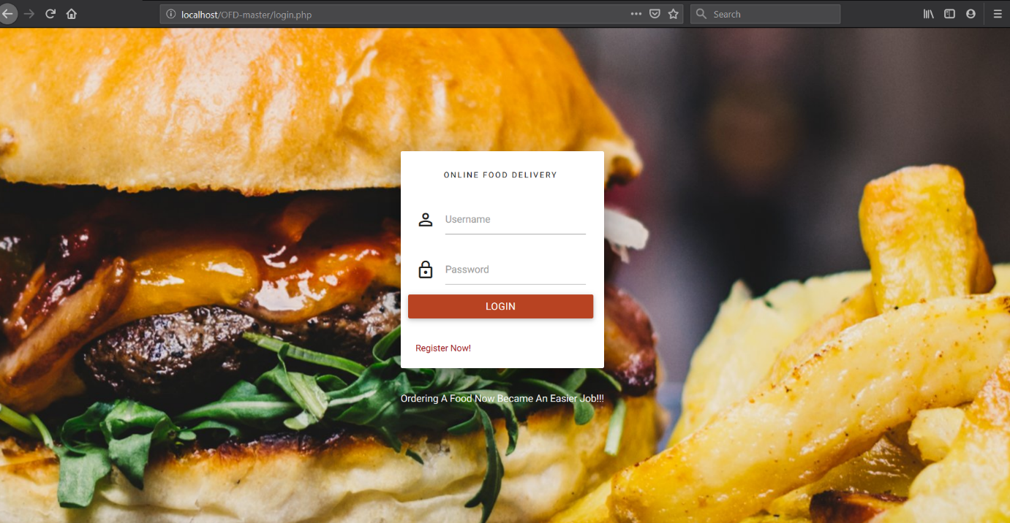

**Fig 7.1 Login Page**

**7.2 Snapshot-2**

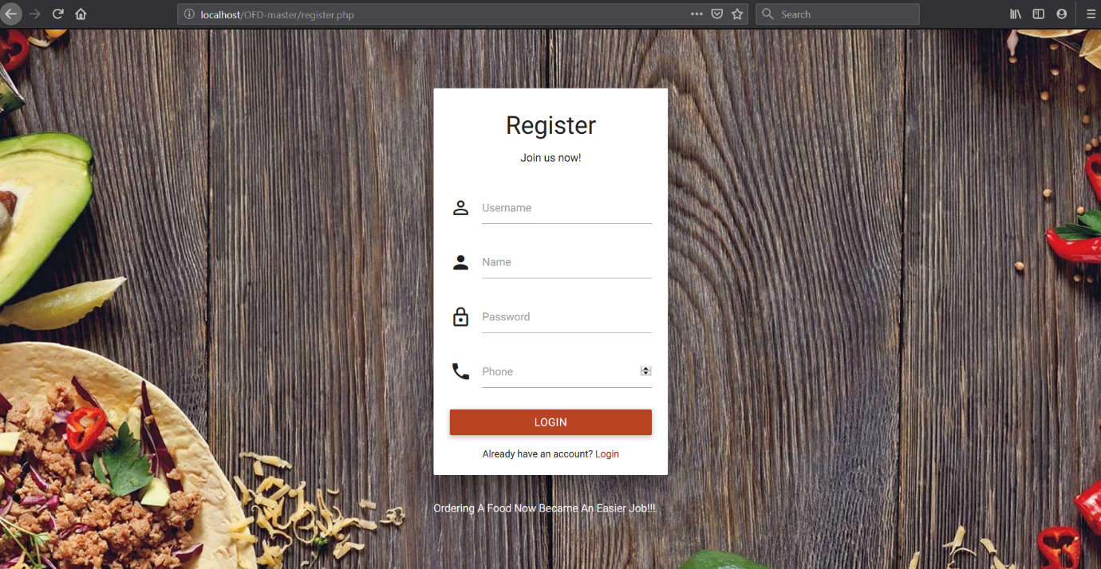

**Fig 7.2 Register Page**

**7.3 Snapshot-3**

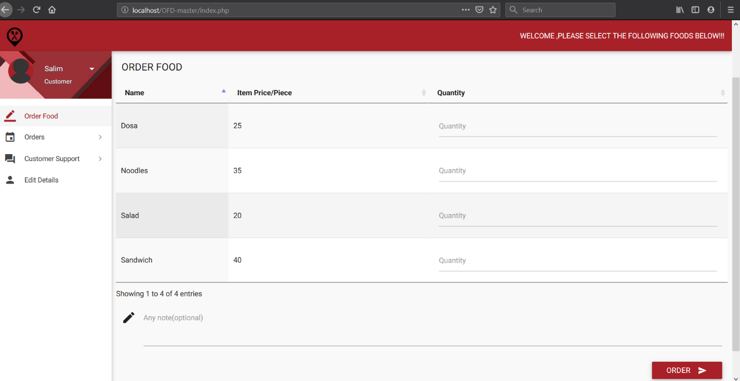

**Fig 7.3 Orders Page**

**7.4 Snapshot-4**

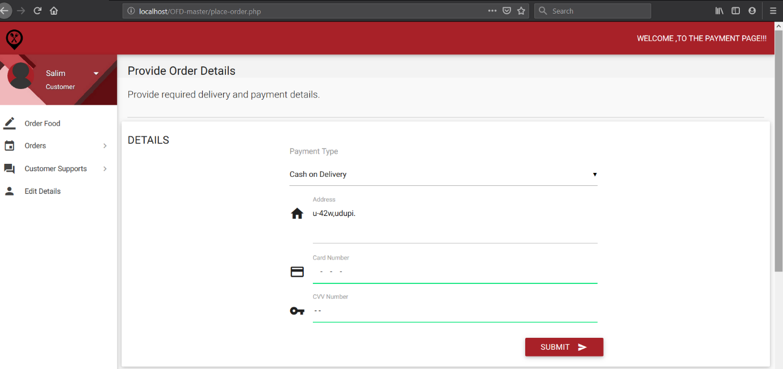

**Fig 7.4 Payment Page**

**7.5 Snapshot-5**

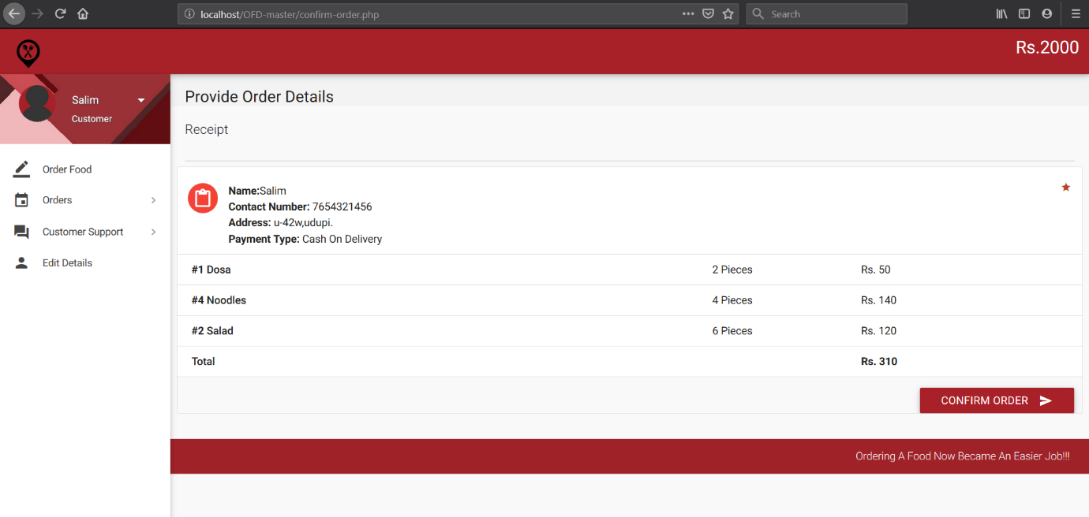

**Fig 7.5 Confirm Order Page**

**7.6 Snapshot-6**

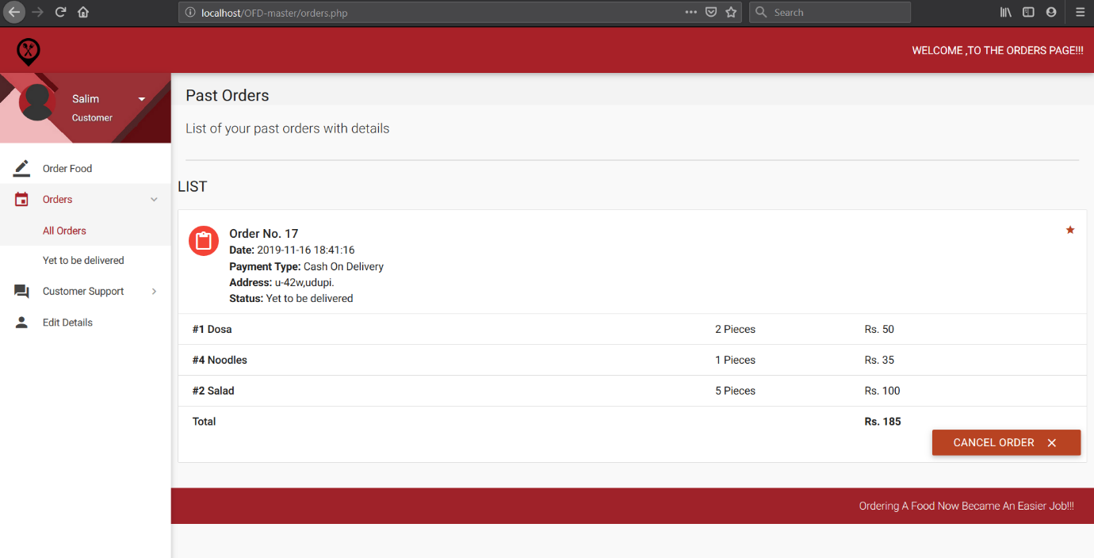

**Fig 7.6 All Orders Page**

**7.7 Snapshot-7**

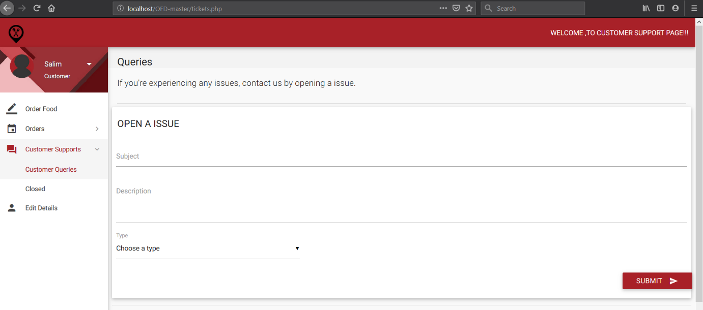

**Fig 7.7 Customer Support Page**

**7.8 Snapshot-8**

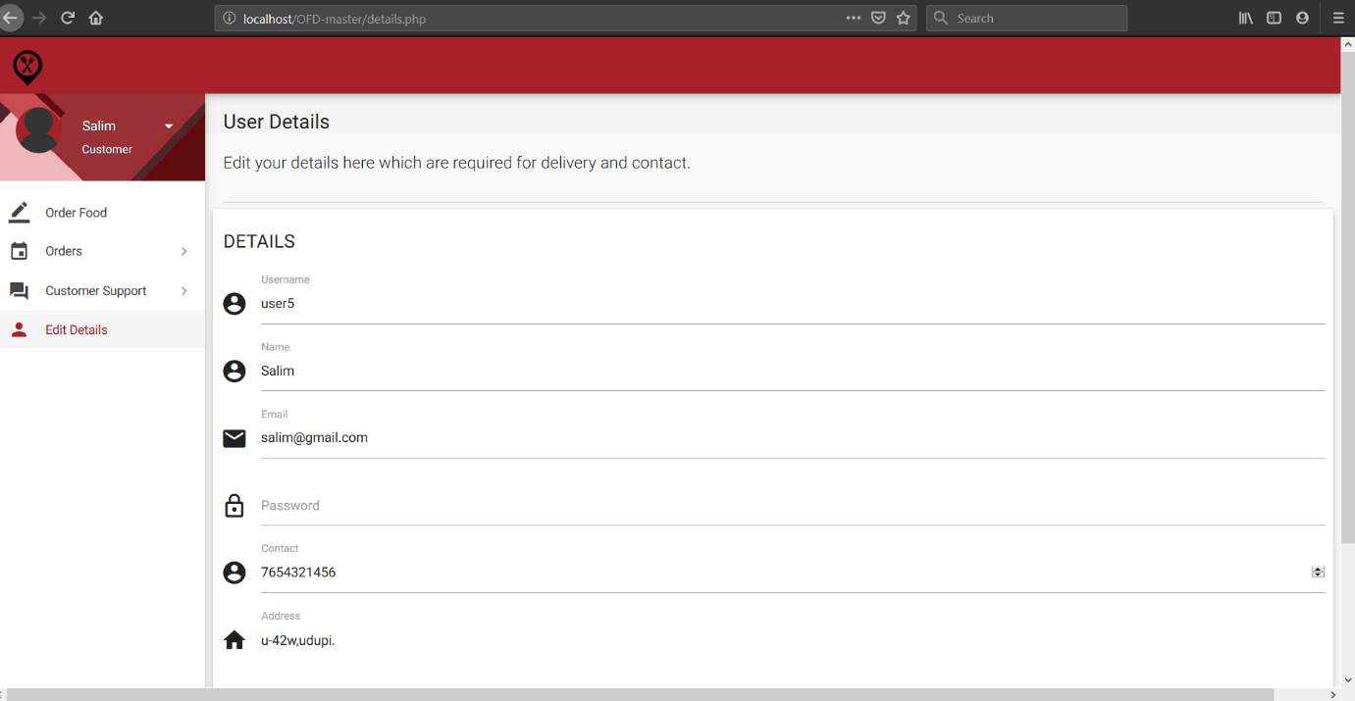

**Fig 7.8 Edit Customer Details page**

# CHAPTER-8

# CONCLUSION AND FUTURE ENHANCEMENT

# 8.1 Conclusion

The online food delivery system is preferred to use rather than the manual system because it offers many advantages and benefits that lead to its effectiveness, and efficiency. Because of the increased confidence on the users on the system, it can be concluded that the online food delivery system enhances food ordering system because it provides better ways of handling the various processes in food orders.

# 8.2 Future Enhancement

# The following features can be implemented in future:

# Allow customers to customize food orders.

# The user interface can be enhanced by adding more interactive features, providing deals and offer details in the home page.

# The payment options can be added such as PayPal, google pay, gift cards etc.

# The visual graphical order can be provided to the customers to track their food orders.